Mrs. Woessner - woessnera@scsk12.org
Website: www.awoessner.weebly.com
Grades will be calculated with the following weights:
40% Tests
25% Quizzes
25% Classwork/Participation
10% Homework

GRADING SCALE
A: 100-93
B: 92-85
C: 84-75
D: 74-70
F: 69-0
Daily Supplies: Composition book, lined paper, graph paper, pencils, calculator.
The following items are needed in the classroom: Glue stick, disinfecting wipes, compass, protractor, ream of printer paper, and dry erase markers.

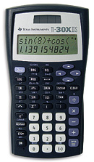
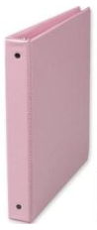
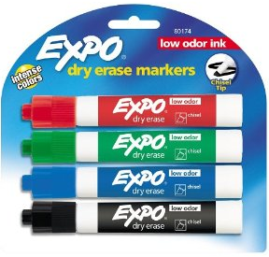
Assignments: Daily assignments are due at the beginning of the period the day after the section has been covered in class. The students’ notebook will be checked periodically and without warning and counted as a participation grade.

Grade improvement opportunities: Students will take a nine weeks test that will count as a test grade; it can also be used to replace their lowest previous test grade for that quarter.
Extra Credit will be offered to the entire class on occasion and will be due when it is due. Extra Credit will not be assigned on a student-to-student basis.

***MAKEUP WORK***
Makeup work and tests/quizzes are the student’s responsibility. After an absence, tests must be made up immediately upon return to class. If the absence has been long enough that the tests have been returned to the class, the nine weeks test grade will be used as the missed test grade. If the student does not make up a test, the 9 weeks test grade will replace the missing test grade.

ISS: Time spent in ISS is considered as regular class time. The student must take their book to ISS and complete the topics covered during class. Scheduled tests will be taken in ISS.

Being absent or in ISS the day before a scheduled test or quiz does not excuse the student from taking it.

Calculators will NOT be provided.

Students must bring a calculator to class every day. Students will not pass calculators back and forth during class, or during a test or quiz. This will result in an automatic zero for both students. Graphing calculators are not required, but are recommended as the student progresses in mathematics.

QUIZZES
Quizzes may be given at any time; announced or unannounced. They may cover vocabulary, homework, bell work or items from the book.

Be prepared for a quiz at any time.

TN Ready STATE EXAM
Geometry students are required to take a state-mandated exam near the end of the school year.

CONSEQUENCES FOR BREAKING THE RULES:
Lowering of conduct mark
Student/parent conference
Referral to grade-level administrator

REWARDS FOR FOLLOWING THE RULES:
Conduct grade of S or E
Satisfaction of a job well done
Self-discipline
A safe, enjoyable classroom environment
You will be expected to complete your book assignments at home; therefore you may leave your book at home. If this policy changes, I will let you know.

Cheating is the unauthorized “getting” of answers/work from someone else or the “giving” of answer/work to someone else.

Copying someone else’s homework is CHEATING.
Notebook

Students will be required to keep a composition book notebook through the year. In this notebook students will put review notes and interactive learning tools.
CLASSROOM RULES:
1. Sit in your assigned seat.
2. Come to class prepared with all required
supplies.
3. Be Respectful. No teasing or checking.
4. Be on task and attentive at all times.
5. Do not disrupt the learning environment of
the classroom.
7. Know and follow all GHS and SCS rules
and policies.

Mathematics requires a specific process of thinking and doing. Students must

SHOW ALL WORK!

On classwork, homework, projects, tests and quizzes, at all times, students are expected to demonstrate that they understand the process and relationships used to arrive at their answer.

HOMEWORK
Daily homework will be counted for accuracy and/or for completion.
No late homework will be accepted.

Put your name on every paper!
Use PENCIL!
Show all work!

BE ON TIME!

TARDIES – Be ready in your seat when the bell rings – have all backpacks and bags stored under your desk and have all materials on your desk!

ELECTRONICS – Absolutely NO phones or headphones allowed. No iPads, iPods, kindles, nooks, cameras, computers, etc.
Shelby County Schools offers educational opportunities without regard to race, color, national origin, religion, sex, or disability.

